Week 7

Grasp – General, Responsibility, Assignment,Software, Patterns – Controller Pattern

Class diagrams + Public, - Private

Architectural Patterns: Presenting a fundamental structuring schema for a software system e.g. MVC

Design Patterns: Providing a scheme for refining the subsystems or components of a software system

General Patterns – things Like Grasp giving a fundamental approach for assigning responsibilities to a objects

Specific Design patterns for more specific but common contexts/problems e.g. observer. Usually specific enough to include a UML modes of the outline solution

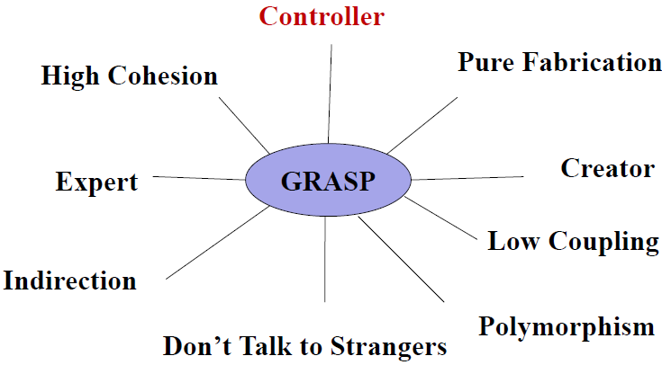

Note ! : Coupling refers to the messaging passing, i.e. invoking methods between objects